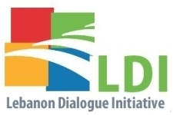

‘The Father Walid Moussa Award in Civic Engagement’
for NDU Students

APPLICATION FORM FOR 2017

1- Applicant Information
Full Name/ Group Name:
Date of Birth: | Country of Birth: |  | Male / Female
Current Address:
Telephone: |  | E-mail:
2- How Many Participants Are You: [ ]
3- Type of Submission: PPP [ ] Video [ ]
4- Briefing About the Activity/Project - Type or paste your introduction (maximum 200 words)
5- Photo Captions Type or paste the captions of the photos you are submitting
6- Attachments
Please note that by submitting this application, you confirm that you have read and agreed to the Rules and Regulations of this competition.

